**程序代码：**

#include <iostream>

using namespace std;

static float m_classMoney = 1000;

class TStudent

{

char* name;

public:

void InitStudent(char name[])

{

name = name;

}

void ExpendMoney(float money, char name[]);

void showMoney();

};

void TStudent::ExpendMoney(float money, char name[])

{

m_classMoney -= money;

cout << name << "花费班费" << money << "元" << endl;

}

void TStudent::showMoney()

{

cout << "班费还剩余" << m_classMoney <<"\n" << endl;

}

int main()

{

TStudent stu[3];

char name[3][100];

int i;

double money[3] = { 50,98.5,500.53 };

for (i = 0; i < 3; i++)

{

cout << "请输入姓名:";

cin >> name[i];

stu[i].InitStudent(name[i]);

stu[i].ExpendMoney(money[i],name[i]);

stu[i].showMoney();

}

}

**结果：**

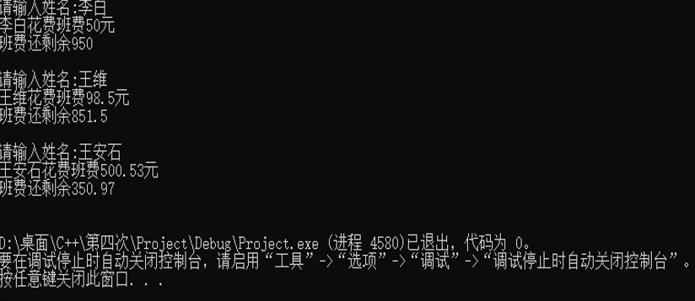

实验感想：

这个主要了解的是静态函数，

课堂上没怎么理解上机后突然明白了很多

静态函数由关键字 static 修饰

Copyright ©2021-2099 CHENGCHI. All rights reserved